MODERN AMERICAN HISTORY
FALL 2019, HISTORY 2042
PROFESSOR CAPÓ

EXHIBITION REFLECTION
DUE VIA CANVAS NO LATER THAN DECEMBER 10, 2019

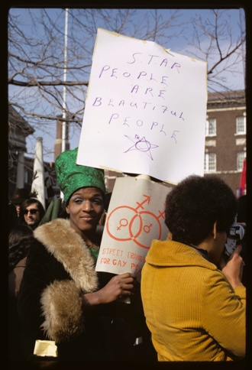

Diana Davies, Gay Rights Demonstration in Albany, NY, 1971, Digital print, 14 x 11 inches, The New York Public Library/Art Resource, NY

As part of your University Core Curriculum (UCC) requirements, you will be visiting the Patricia & Phillip Frost Art Museum, located at FIU’s MCC campus. Our semester coincides with a new exhibition titled, Art after Stonewall, 1969-1989. It is curated by Jonathan Weinberg, as well as Daniel Marcus and Drew Sawyer. As you will note throughout the exhibition, this sweeping effort helps commemorate the 50th anniversary of the Stonewall rebellion in New York City that helped bring about a new radical and more concentrated gay liberation movement in the United States and beyond. You can find more information on the exhibition here.

Worth 15% of your final grade, this assignment asks that you make a meaningful visit to the exhibition. You will not incur any cost to visit the museum. Regular museum hours are Tuesday through Saturday, from 10am to 5pm; on Sundays, it’s open from noon to 5pm. It is closed on Mondays and most legal/university holidays (including November 28-29). You should confirm with the museum to make sure it is open when you intend to visit.

Visit the gallery and take some time to observe the different forms of art that reflect this moment in U.S. history. While it tells elements of the LGBTQ (lesbian, gay, bisexual, transgender, and queer) communities’ history in the United States, it also reflects, at its core, histories of race relations, immigration, feminism, class warfare and poverty, access to healthcare, foreign relations, and much, much more. Be mindful about how these stories are interwoven in this artwork.

As you visit the exhibition, take notice of two distinct pieces of art featured in the exhibition. Write about them, as primary sources, in two distinct responses of no more than 250 words. That is, in the end, you should have two 250-word responses reflecting on a given work of art of your choosing featured in this exhibition. Rely on our class lectures, reaction assignments and sources, assigned readings, and even the exhibition labels featured in the museum to offer the necessary historical context in your analysis of the piece. You are not permitted to use any other outside sources for your response.

Your responses should be double-spaced, and typed in either Calibri, Arial, or Times New Roman font with standard margins (1 inch). Be sure to number your pages and to provide the exact word count for each response with your title.

Each reflection should include a header with word count and the title of the object as it listed in the exhibition. It should also concisely answer: 1) what is the piece? What is its format and medium? For whom was it intended?; 2) what is its message?; 3) how does it reflect some of the key issues, debates, or social and political circumstances of the era in which it was produced?

Extra Credit Opportunity

This assignment is also an opportunity to earn extra credit. You have the option of submitting an additional analytical reflection on a distinct, third piece featured in the exhibition. As with the others, your response should be no more than 250 words in length. Kindly follow all the other instructions above. You may earn up to 20 additional points on this assignment with this extra credit submission, which should be included in the same document and headed: “Extra Credit” along with the word count.

